1. **Build life cycle** is one of the most important pieces in maven landscape.
2. Life cycle helps us when we build, test or distribute an artifact.
3. The life cycle consists of a set of steps, or stages, that we go through as we build our artifact.
4. These stages are referred to as **phases.**
5. **3 built-in life cycles.**
   1. **Default Life Cycle**
   2. **Clean Life Cycle**
   3. **Site Life Cycle**
6. Each life cycle has its own particular phases.
7. Particular goals are bound to a particular phase in a life cycle.
8. Goal is an action on our project.
9. Let’s see a quick demonstration to see a phase in action.
10. 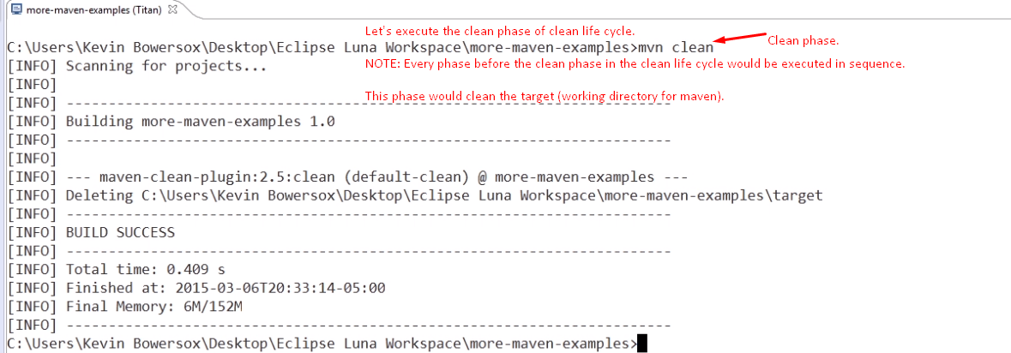
11. This lecture is not completed. Do it.